Requirements/Design Specification

**Existing Cust VCD not on CSA**

**GH 458 – CR 13939**

Revision History

|  |  |  |  |
| --- | --- | --- | --- |
| **Date** | **Revision** | **Description** | **Author** |
| 4/29/2015 | 1.0 | Initial Version with Requirements | Roger Behm |
|  |  |  |  |
|  |  |  |  |
|  |  |  |  |
|  |  |  |  |

The information furnished herein by Republic Services Inc. is proprietary and confidential to Republic Services Inc. personnel and is not to be duplicated, published, or disclosed to any third party in whole or in part without permission from Republic Services, Inc.

© Copyright 2012, Republic Services Inc. - All rights reserved.

Table of contents

1 Business Requirements/Owner – Brittany Smith 6

2 Assumptions 7

3 Design 7

4 InfoPro/TIBCO/BI Impacts 7

5 Report Changes 7

6 Appendix 7

# Business Requirements/Owner – Brittany Smith

If you do a quote for an existing customer and add a new container with a VCD but do not click on the CSA box on the Generate Docs page, you are able to finalize and the VCD will not show up on the notes. The bigger bug is that you are able to click Next without clicking the CSA box.

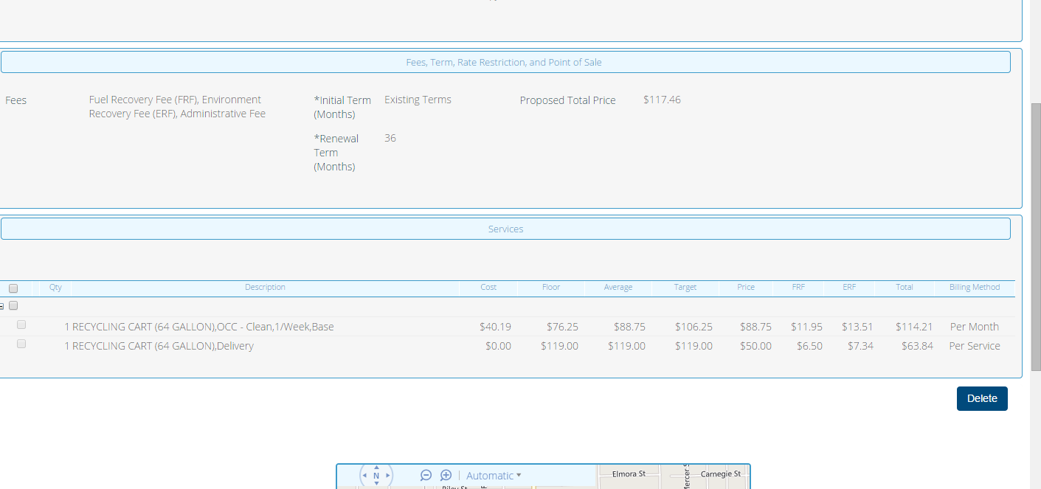

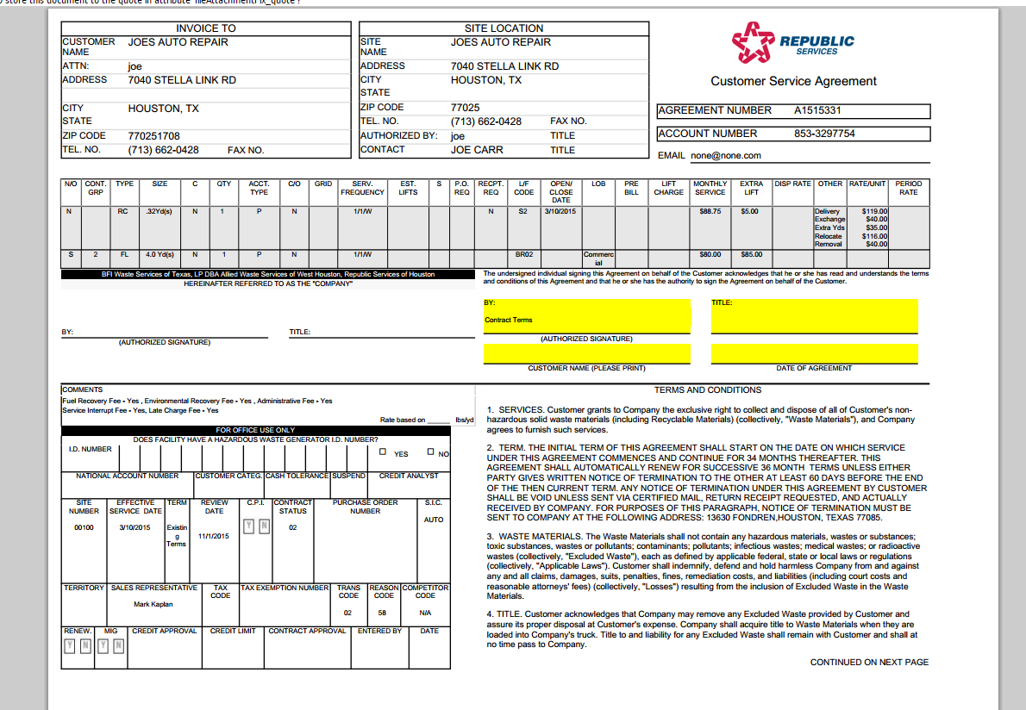

# Assumptions

NA

# Design

Display the VCD on the office use CSA regardless of the customer CSA was printed. Add validation for existing customers to ensure the customer CSA checkbox on the Generate Docs page is checked. Commerce function "commentsForDeliveryAndExchangeCreditOnOutput" should be run only in the case of "Print Documents" action.

# InfoPro/TIBCO/BI Impacts

No new variable should be needed and no existing variables should be repurposed for any of the above changes.

# Report Changes

NA

# Appendix